Create a Snapshot of a VM and Test it by loading the Previous Version/Cloned VM.

Procedure:

Step1: Creating a snapshot of a Virtual Machine.

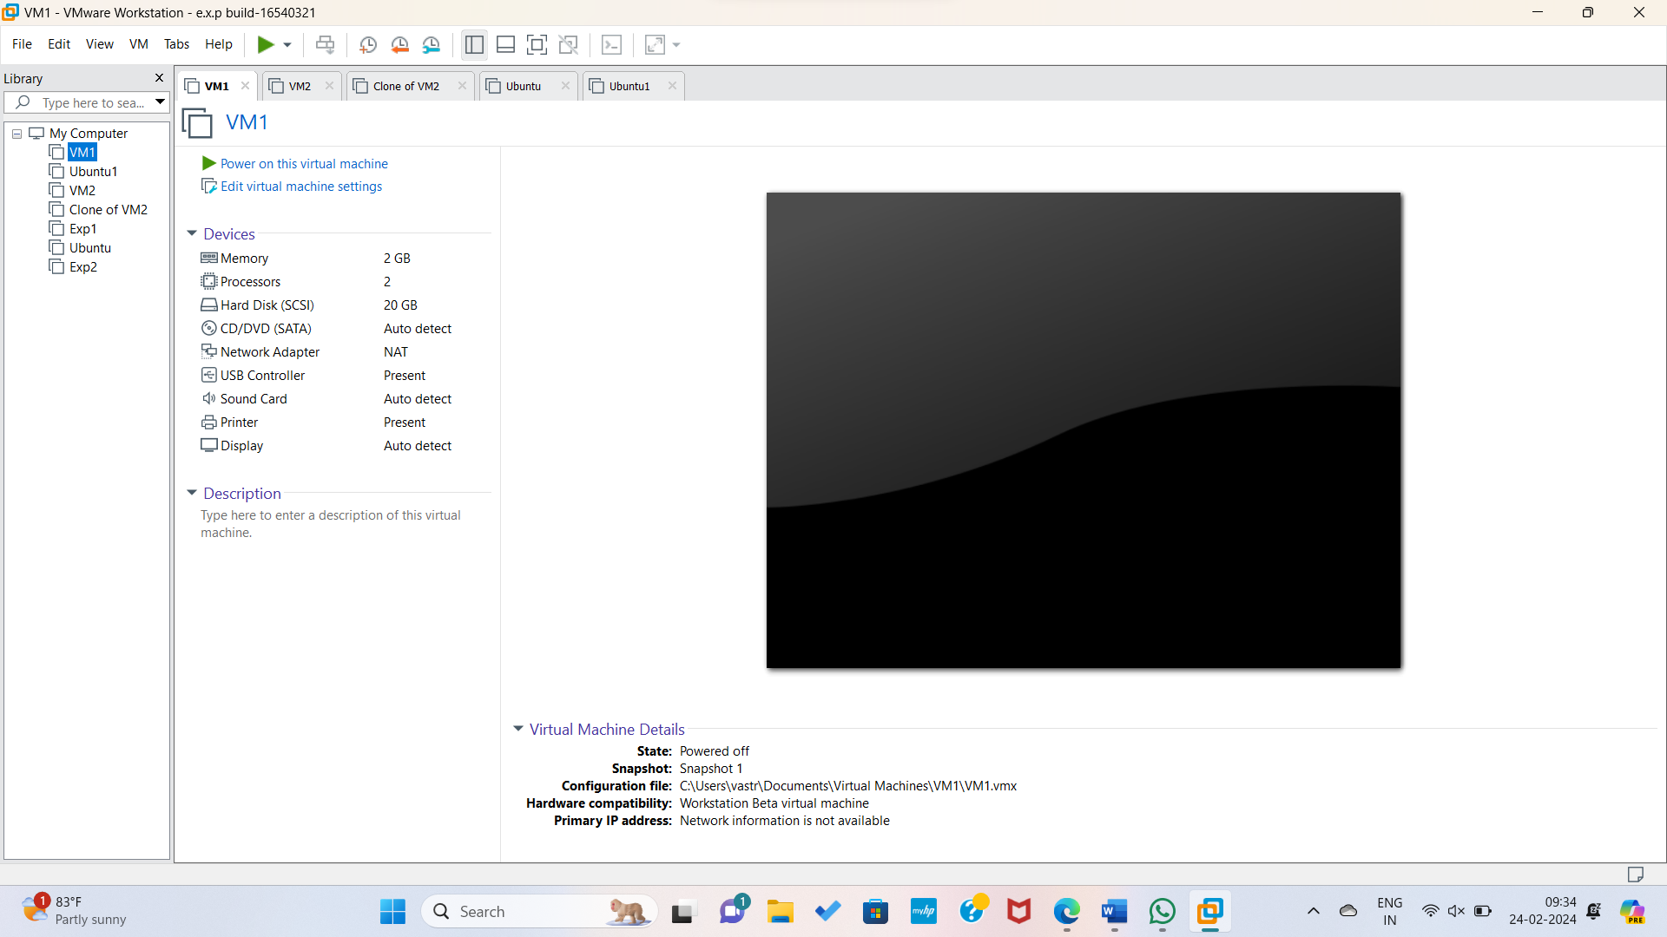

Step2: Changing Parameters for the Snapshot.

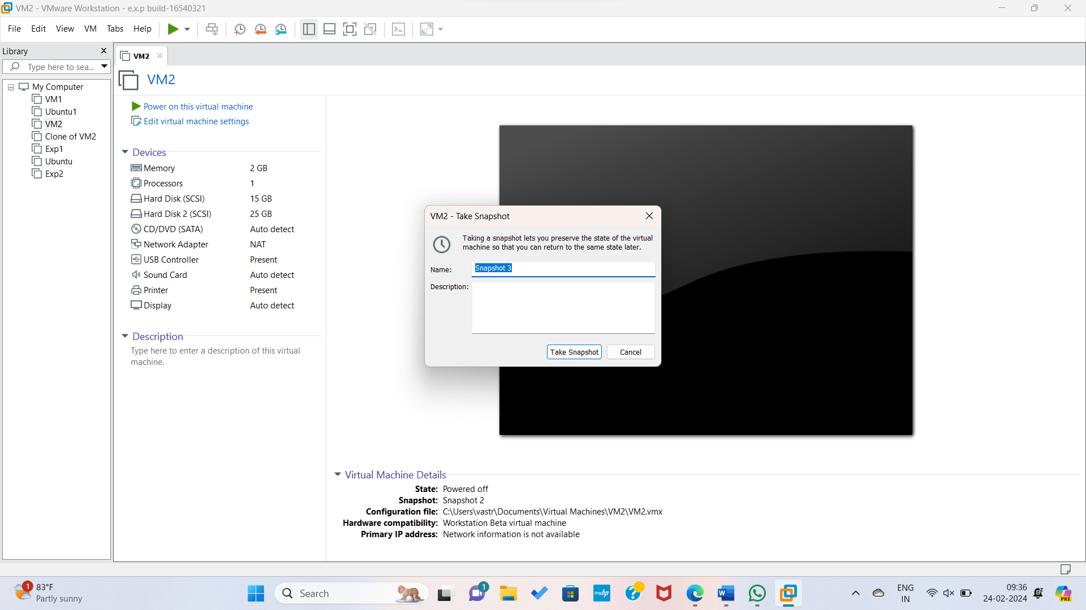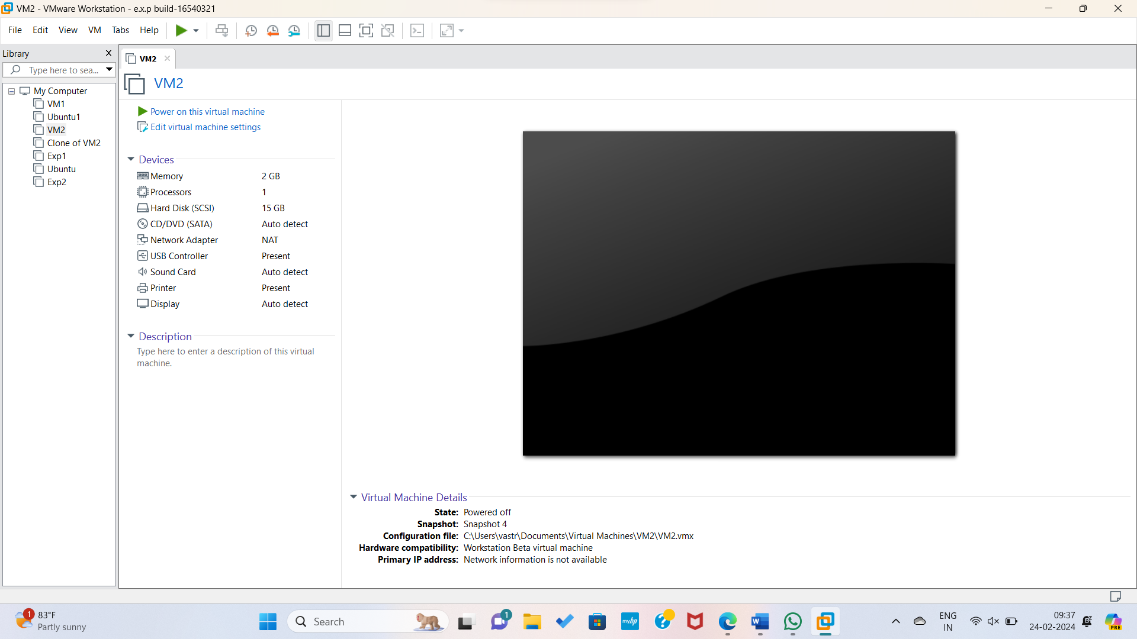Step3: Changing the processor in the VM.

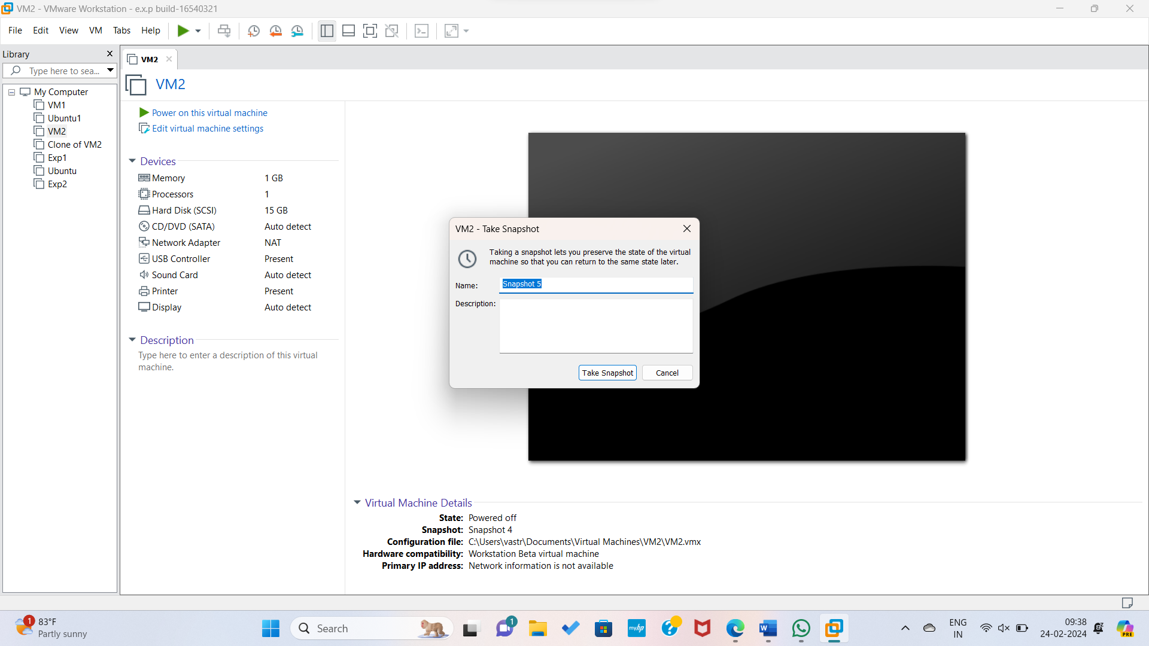

Step4: Hence the parameters changed and snapshots created Successfully.

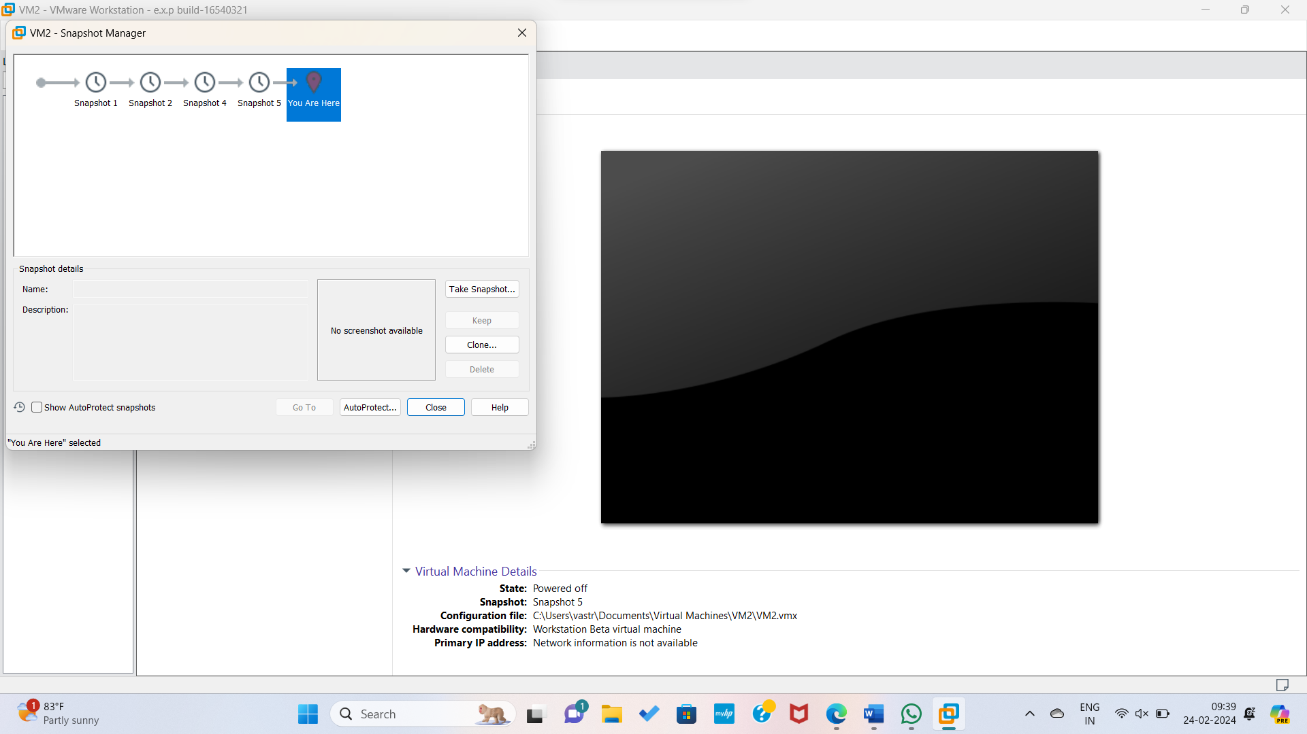

Step5: Hence the snapshot changed successfully.

